Instructor Teaching Tracker

Brandon R. Russell

University of Maryland University College

Contents

Statement of Work 2

Entity Relationship Diagram 3

Table Design 4

Data Definition 5

Insert Data 12

# Statement of Work

1. This database supports the Instructor Teaching Tracker application. It keeps track of Instructor, course, and section data, as well as classes taught and schedule. The purpose of this is to assist Instructors with scheduling/maintaining classes in an efficient manner.

The Instructor table has the name, address, phone number and section number. The course list has the course name, author, description, hours and section number. The section table has the section number, name, address and field of study. The Instructor Classes table shows the Instructor, schedule, course, room number and Instructor notes. The class schedule gives the day/time a class is taught, a down day schedule and notes.

For this application a section can have many Instructors, but an Instructor can only belong to one section. A section can control many courses, but a course can belong to only one section. An instructor can teach many classes and a class can be taught by many instructors; this is handled with an associative entity. Many classes can be generated from one course, but each class can only be generated from a single course. One class can have only one schedule, while many classes can have the same schedule.

Assumptions: This application tracks classes taught by instructors and includes a class schedule. It is assumed classes will always meet a specific schedule criteria of Monday-Wednesday-Friday, Tuesday-Thursday, or Saturday. Down days are tracked for individual classes since this will vary based upon the specific class.

1. Database: Oracle 11g on Windows platform.
2. Software: ER Assistant, Oracle SQL developer, and Oracle SQL developer data modeler.
3. DDL – drop and create the database objects including tables, views, triggers, and sequences. DML – populate and query data.

# Entity Relationship Diagram

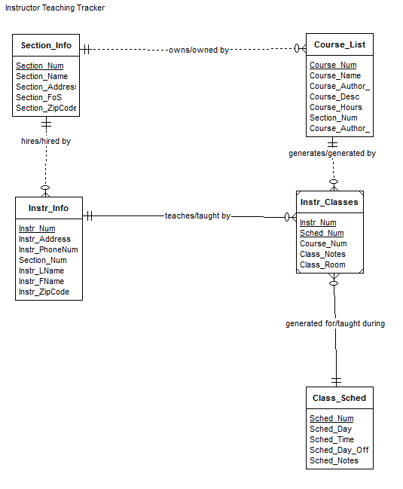

# Table Design

|  |  |  |
| --- | --- | --- |
| Section_Info | | |
| Section_Num | INTEGER | Not null - pk |
| Section_Name | VARCHAR(100) |  |
| Section_Address | VARCHAR(100) |  |
| Section_FoS | VARCHAR(100) |  |
| Section_ZipCode | VARCHAR(10) |  |

|  |  |  |
| --- | --- | --- |
| Course_List | | |
| Course_Num | INTEGER | Not null – pk |
| Course_Name | VARCHAR(100) |  |
| Course_Author_FName | VARCHAR(20) |  |
| Course_Author_LName | VARCHAR(20) |  |
| Course_Desc | VARCHAR(1000) |  |
| Course_Hours | INTEGER |  |
| Section_Num | INTEGER | Not null - fk |

|  |  |  |
| --- | --- | --- |
| Instr_Info | | |
| Instr_Num | INTEGER | Not null – pk |
| Instr_Address | VARCHAR(100) |  |
| Instr_PhoneNum | VARCHAR(20) |  |
| Section_Num | INTEGER | Not null - fk |
| Instr_LName | VARCHAR(20) |  |
| Instr_FName | VARCHAR(20) |  |
| Instr_ZipCode | VARCHAR(10) |  |

|  |  |  |
| --- | --- | --- |
| Class_Sched | | |
| Sched_Num | INTEGER | Not null - pk |
| Sched_Day | VARCHAR(100) |  |
| Sched_Time | VARCHAR(10) |  |
| Sched_Day_Off | VARCHAR(100) |  |
| Sched_Notes | VARCHAR(1000) |  |

|  |  |  |
| --- | --- | --- |
| Instr_Classes | | |
| Instr_Num | INTEGER | Not null – pk/fk |
| Sched_Num | INTEGER | Not null – pk/fk |
| Course_Num | INTEGER | Not null - fk |
| Class_Notes | VARCHAR(1000) |  |
| Class_Room | VARCHAR(5) |  |

# Data Definition

SET echo on

SET serveroutput on

**/* Drop tables, sequence, and other objects you create*/**

DROP TABLE Instr_Classes;

Table INSTR_CLASSES dropped.

DROP TABLE Instr_Info;

Table INSTR_INFO dropped.

DROP TABLE Course_List;

Table COURSE_LIST dropped.

DROP TABLE Section_Info;

Table SECTION_INFO dropped.

DROP TABLE Class_Sched;

Table CLASS_SCHED dropped.

DROP SEQUENCE SectionNum_Seq;

Sequence SECTIONNUM_SEQ dropped.

DROP SEQUENCE InstrNum_Seq;

Sequence INSTRNUM_SEQ dropped.

DROP SEQUENCE CourseNum_Seq;

Sequence COURSENUM_SEQ dropped.

DROP SEQUENCE SchedNum_Seq;

Sequence SCHEDNUM_SEQ dropped.

**/* Create 5 tables */**

CREATE TABLE Section_Info

(

Section_Num INTEGER NOT NULL,

Section_Name VARCHAR (100),

Section_Address VARCHAR (100),

Section_FoS VARCHAR (100),

Section_ZipCode VARCHAR(10),

CONSTRAINT pk_section PRIMARY KEY (Section_Num)

);

Table SECTION_INFO created.

DESCRIBE Section_Info;

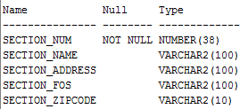

CREATE TABLE Instr_Info

(

Instr_Num INTEGER NOT NULL,

Instr_Address VARCHAR (100),

Instr_PhoneNum VARCHAR (20),

Section_Num INTEGER NOT NULL,

Instr_LName VARCHAR (20),

Instr_FName VARCHAR (20),

Instr_ZipCode VARCHAR (10),

CONSTRAINT pk_Instr PRIMARY KEY (Instr_Num),

CONSTRAINT fk_Instr_Section FOREIGN KEY (Section_Num)

REFERENCES Section_Info

);

Table INSTR_INFO created.

DESCRIBE Instr_Info;

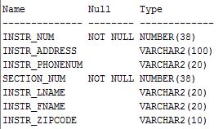

CREATE TABLE Course_List

(

Course_Num INTEGER NOT NULL,

Course_Name VARCHAR (100),

Course_Author_FName VARCHAR (20),

Course_Author_LName VARCHAR(20),

Course_Desc VARCHAR (1000),

Course_Hours INTEGER,

Section_Num INTEGER NOT NULL,

CONSTRAINT pk_Course PRIMARY KEY (Course_Num),

CONSTRAINT fk_Course_Section FOREIGN KEY (Section_Num)

REFERENCES Section_Info

);

Table COURSE_LIST created.

DESCRIBE Course_List;

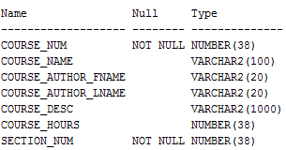

CREATE TABLE Class_Sched

(

Sched_Num INTEGER NOT NULL,

Sched_Day VARCHAR (100),

Sched_Time VARCHAR (10),

Sched_Day_Off VARCHAR (100),

Sched_Notes VARCHAR (1000),

CONSTRAINT pk_Schedule PRIMARY KEY (Sched_Num)

);

Table CLASS_SCHED created.

DESCRIBE Class_Sched;

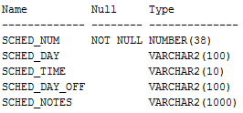

CREATE TABLE Instr_Classes

(

Instr_Num INTEGER NOT NULL,

Sched_Num INTEGER NOT NULL,

Course_Num INTEGER NOT NULL,

Class_Notes VARCHAR (1000),

Class_Room VARCHAR (5),

CONSTRAINT pk_Class PRIMARY KEY (Instr_Num, Sched_Num),

CONSTRAINT fk_Instr FOREIGN KEY (Instr_Num)

REFERENCES Instr_Info

ON DELETE CASCADE,

CONSTRAINT fk_Sched FOREIGN KEY (Sched_Num)

REFERENCES Class_Sched

ON DELETE CASCADE,

CONSTRAINT fk_Course FOREIGN KEY (Course_Num)

REFERENCES Course_List

ON DELETE CASCADE

);

Table INSTR_CLASSES created.

DESCRIBE Instr_Classes;

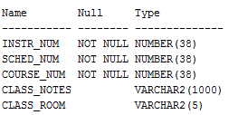

**/* Create indexes on foreign keys*/**

CREATE INDEX fk_Course_List on Course_List(Section_Num);

Index FK_COURSE_LIST created.

CREATE INDEX fk_Instr on Instr_Info(Section_Num);

Index FK_INSTR created.

CREATE INDEX fk_InstrClass on Instr_Classes(Instr_Num);

Index FK_INSTRCLASS created.

CREATE INDEX fk_ClassSched on Instr_Classes(Sched_Num);

Index FK_CLASSSCHED created.

CREATE INDEX fk_CourseClass on Instr_Classes(Course_Num);

Index FK_COURSECLASS created.

**/* Create 2 views */**

**/*This view shows all classes Instructor 1 is teaching on Schedule 1 */**

CREATE OR REPLACE VIEW Instr_Teaching_View AS

SELECT * from Instr_Classes

WHERE Instr_Num ='1' AND Sched_Num ='1';

View INSTR_TEACHING_VIEW created.

DESCRIBE Instr_Teaching_View;

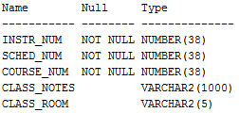

**/*This view will show which section each Instructor belongs to*/**

CREATE OR REPLACE VIEW Section_Instructors_View AS

SELECT section_num, s.section_name, i.instr_fname, i.instr_lname

FROM section_info s

INNER JOIN instr_info i

USING (section_num);

View SECTION_INSTRUCTORS_VIEW created.

DESCRIBE Section_Instructors_View;

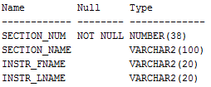

**/* Create trigger */**

**/*This trigger will display a message when a row is added to Instr_Classes*/**

CREATE OR REPLACE TRIGGER SchedClass_Trigger AFTER INSERT ON Instr_Classes

FOR EACH ROW

BEGIN

dbms_output.put_line ('A class has been added!!');

END;

/

Trigger SCHEDCLASS_TRIGGER compiled

**/* Create sequence*/**

CREATE SEQUENCE SectionNum_Seq

START WITH 1

INCREMENT BY 1;

Sequence SECTIONNUM_SEQ created.

CREATE SEQUENCE InstrNum_Seq

START WITH 1

INCREMENT BY 1;

Sequence INSTRNUM_SEQ created.

CREATE SEQUENCE CourseNum_Seq

START WITH 1

INCREMENT BY 1;

Sequence COURSENUM_SEQ created.

CREATE SEQUENCE SchedNum_Seq

START WITH 1

INCREMENT BY 1;

Sequence SCHEDNUM_SEQ created.

**/* Data Dictionary query */**

PURGE recyclebin;

**/*The next query returns the first 20 characters of all table names and then their tablespace names*/**

SELECT /*fixed*/ substr(table_name, 1,20) as name, tablespace_name from user_tables;

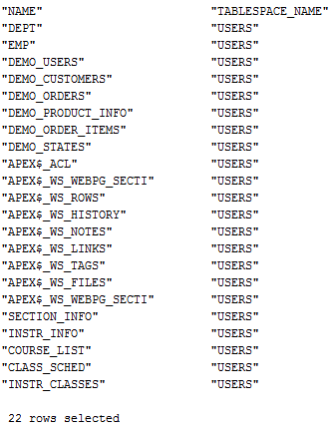

# Insert Data

**/* Insert 10 or more rows into each table */**

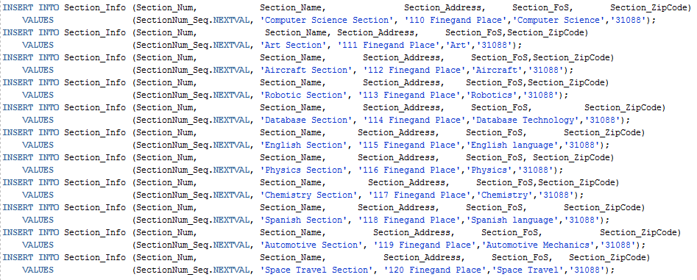

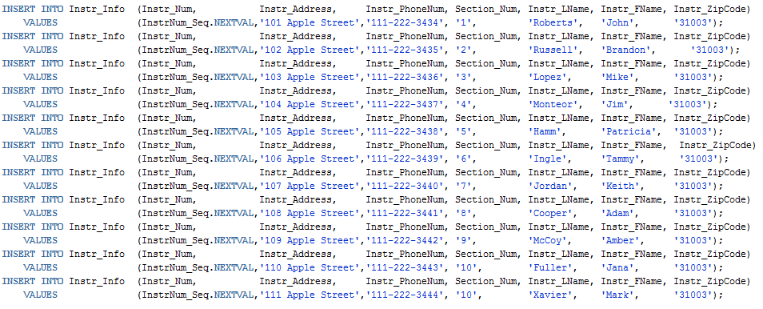

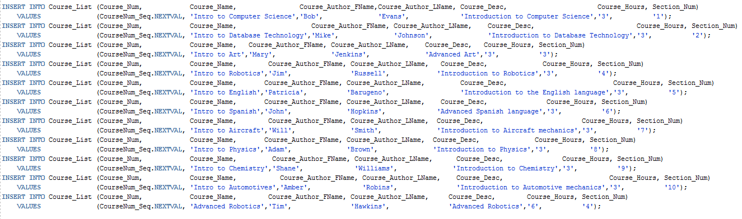

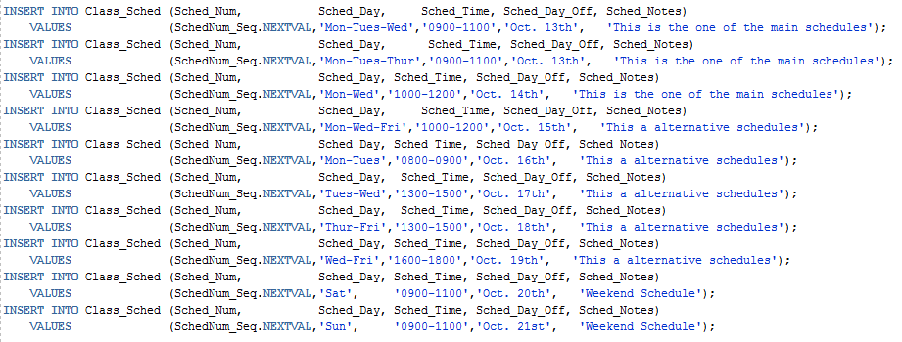

INSERT INTO Instr_Classes (Instr_Num, Sched_Num, Course_Num, Class_Notes, Class_Room)

VALUES ('1', '1', '1', 'Computer one is broke in this room','A');

1 row inserted.

A class has been added!!

INSERT INTO Instr_Classes (Instr_Num, Sched_Num, Course_Num, Class_Notes, Class_Room)

VALUES ('2', '2', '2', 'Room Ready','B');

1 row inserted.

A class has been added!!

INSERT INTO Instr_Classes (Instr_Num, Sched_Num, Course_Num, Class_Notes, Class_Room)

VALUES ('3', '3', '3', 'The Instructor Chair is broke','C');

1 row inserted.

A class has been added!!

INSERT INTO Instr_Classes (Instr_Num, Sched_Num, Course_Num, Class_Notes, Class_Room)

VALUES ('4', '4', '4', 'A/C is not working','D');

1 row inserted.

A class has been added!!

INSERT INTO Instr_Classes (Instr_Num, Sched_Num, Course_Num, Class_Notes, Class_Room)

VALUES ('5', '5', '5', 'Computer two is broke in this room','E');

1 row inserted.

A class has been added!!

INSERT INTO Instr_Classes (Instr_Num, Sched_Num, Course_Num, Class_Notes, Class_Room)

VALUES ('6', '6', '6', 'No whiteboard in this room','F');

1 row inserted.

A class has been added!!

INSERT INTO Instr_Classes (Instr_Num, Sched_Num, Course_Num, Class_Notes, Class_Room)

VALUES ('7', '7', '7', 'Student station 3 is missing a keyboard','G');

1 row inserted.

A class has been added!!

INSERT INTO Instr_Classes (Instr_Num, Sched_Num, Course_Num, Class_Notes, Class_Room)

VALUES ('8', '8', '8', 'Room Ready','H');

1 row inserted.

A class has been added!!

INSERT INTO Instr_Classes (Instr_Num, Sched_Num, Course_Num, Class_Notes, Class_Room)

VALUES ('9', '9', '9', 'Room Ready','I');

1 row inserted.

A class has been added!!

INSERT INTO Instr_Classes (Instr_Num, Sched_Num, Course_Num, Class_Notes, Class_Room)

VALUES ('10', '10', '10', 'Room Ready','J');

1 row inserted.

A class has been added!!

INSERT INTO Instr_Classes (Instr_Num, Sched_Num, Course_Num, Class_Notes, Class_Room)

VALUES ('10', '9', '10', 'Room Ready','J');

1 row inserted.

A class has been added!!

INSERT INTO Instr_Classes (Instr_Num, Sched_Num, Course_Num, Class_Notes, Class_Room)

VALUES ('9', '8', '10', 'Room Ready','X');

1 row inserted.

A class has been added!!

INSERT INTO Instr_Classes (Instr_Num, Sched_Num, Course_Num, Class_Notes, Class_Room)

VALUES ('1', '2', '9', 'Room Ready','Z');

1 row inserted.

A class has been added!!

commit;

Commit complete.

**/* Verify that each table has 10 or more rows of data */**

SELECT /*fixed*/ * FROM Section_Info;

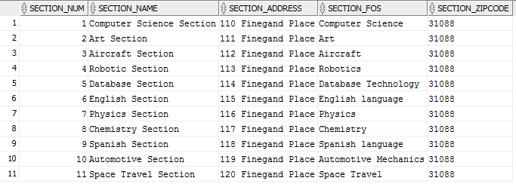

SELECT /*fixed*/ * FROM Instr_Info;

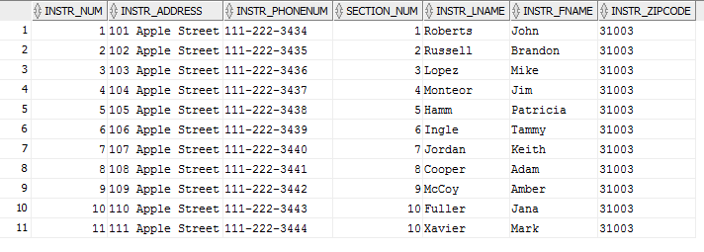

SELECT /*fixed*/ * FROM Course_List;

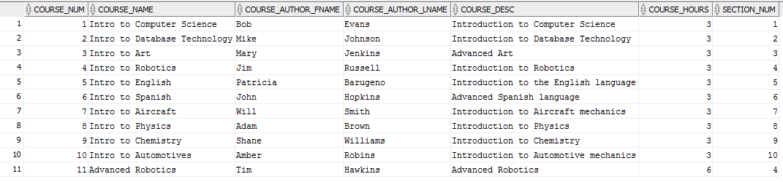

SELECT /*fixed*/ * FROM Class_Sched;

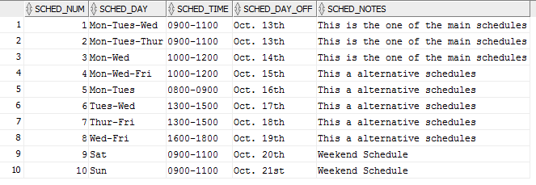

SELECT /*fixed*/ * FROM Instr_Classes;

